**Hands on 4**

**Spring Core – Load Country from Spring Configuration XML**

**CODE:**

Spring-learn-handson4/pom.xml

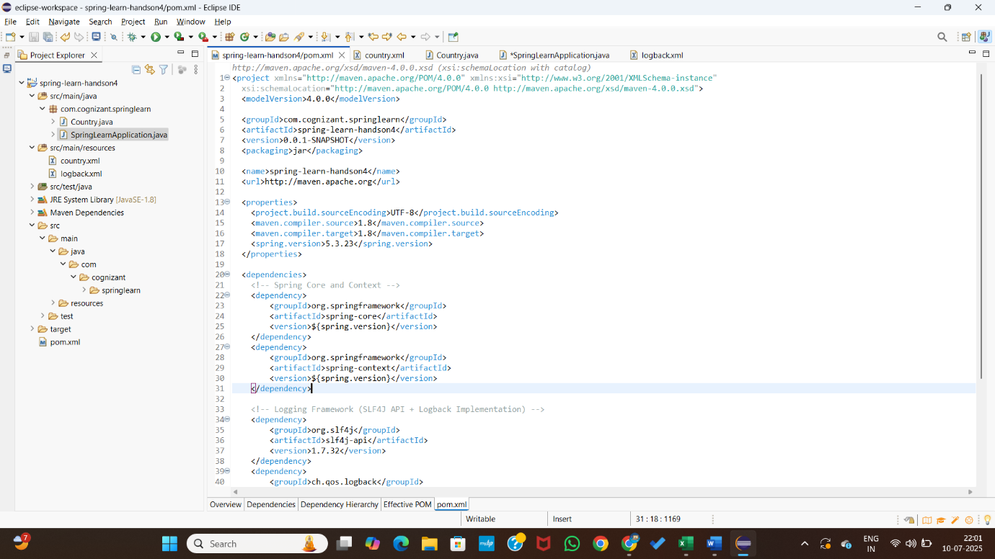

country.xml

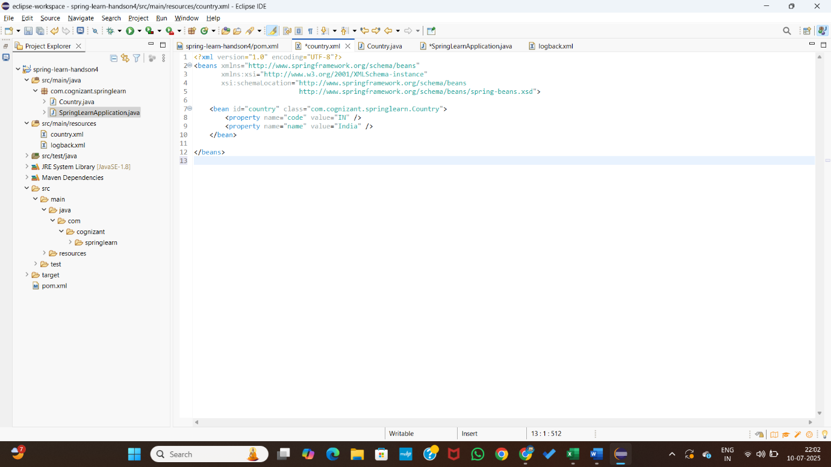

Country.java

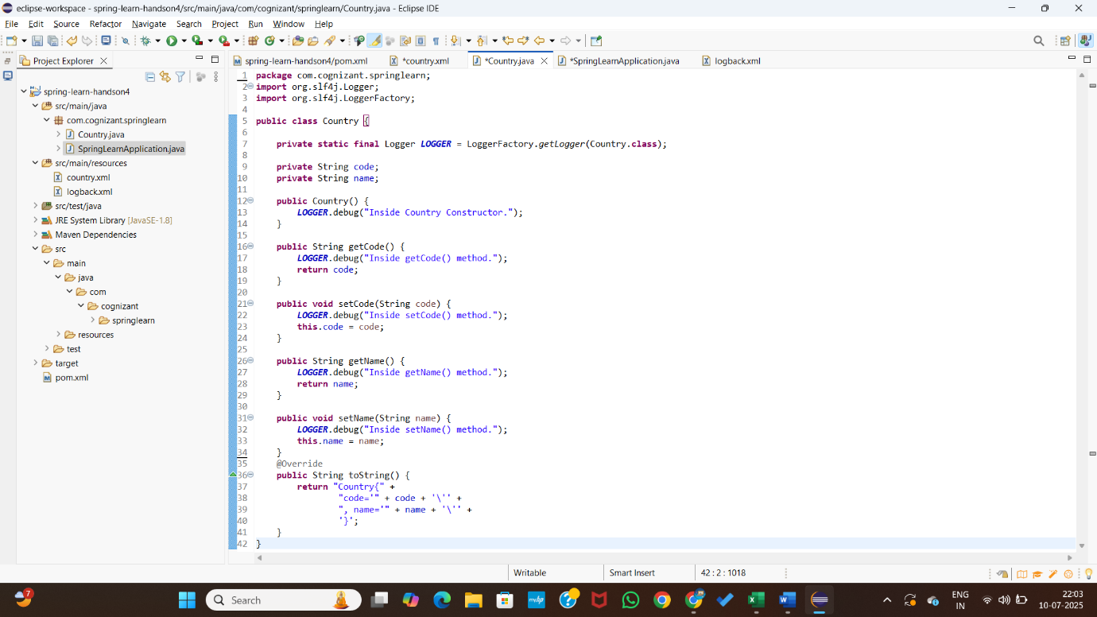

SpringLearnApplication.java

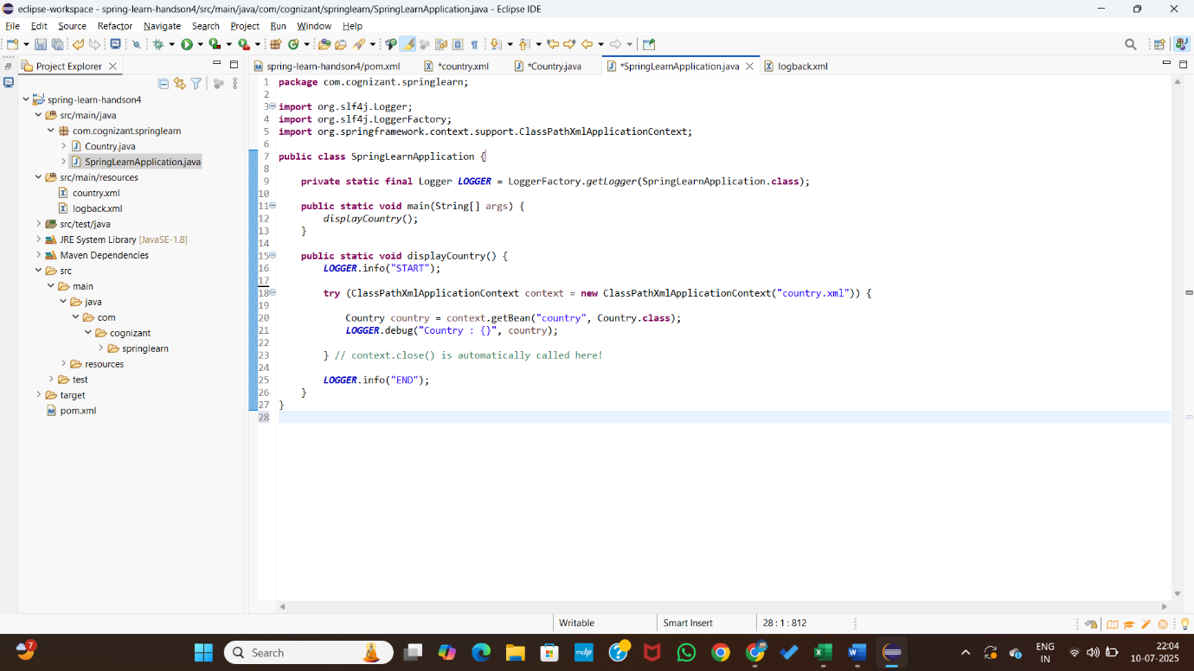

Logback.xml

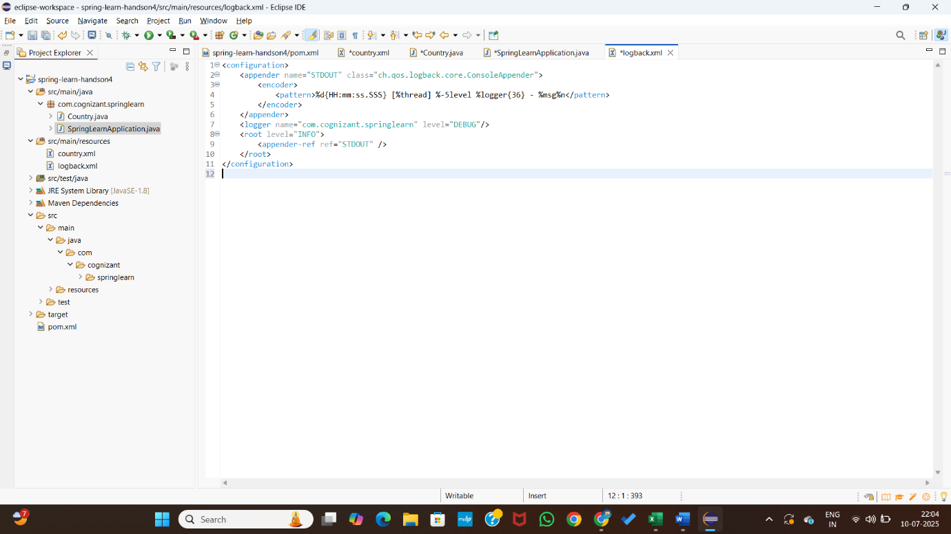

**OUTPUT:**

